### Tasks

- Locate the `useradd` binary on the system.
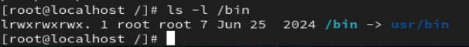
- Check the owner and group of the `useradd` binary.
- Verify the default permissions of the `useradd` command.
- Identify whether SUID is enabled by default or not.
The SUID bit is not set by default on useradd.
- Set the **SUID** permission on the `useradd` binary.
- Verify that the SUID bit is set successfully.
7. Note the permission changes before and after SUID is applied.
### Tasks

8.Create a directory named `sgiddir`.
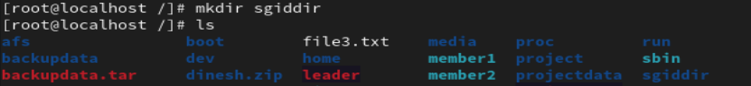
9.Assign a group to the directory.
10. Grant required permissions to group members.
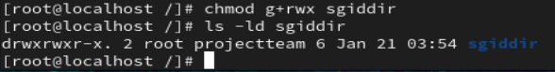

11. Set the **SGID** permission on the directory.
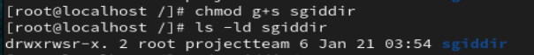
12. Verify that the SGID bit is set.
13. Create a file inside `sgiddir`.
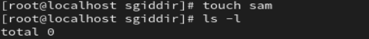
14. Check the group ownership of the newly created file.
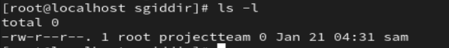
15. Remove the SGID permission from the directory.
16. Verify the change.
### Tasks
17. Create a directory named `sharedir`.
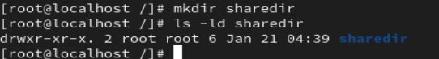
18. Assign permissions so multiple users can create files.
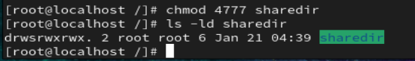
19. Set the **Sticky Bit** on the directory.
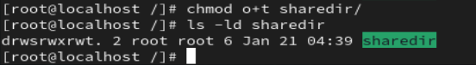
20. Verify that the sticky bit is set.
21. Create files using different users.
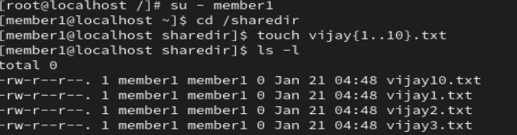
22. Attempt to delete another user’s file.
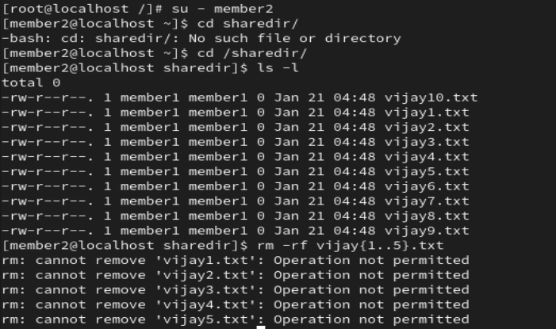
23. Observe the behavior with sticky bit enabled.
Only delete files or directory in same user.otherwise not delete the for anotheruser
24. Remove the sticky bit from the directory.
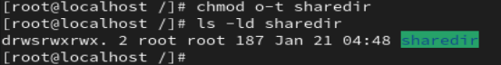
25. Observe the difference after removal.
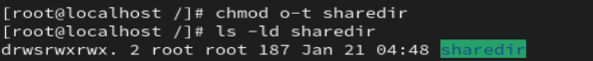

#####################################################################################################################################
- Add groups csk and rcb .

- Create users dhoni, Raina, Virat , and Faf.
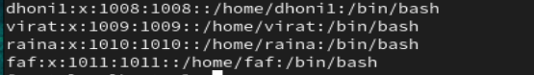
- Add users Dhoni and Raina to the csk group.
- Add users Virat and Faf to the rcb group.
- Create the directory cricket in /.
- Create directories kings and challengers inside the cricket directory.
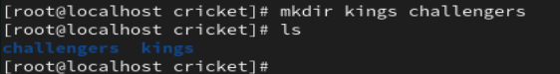
- Set full permissions for the csk group on the kings directory and full permissions for the rcb group on the challengers directory.
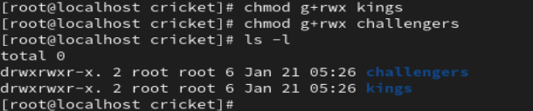
- Change the group ownership of the kings directory to csk and the challengers directory to rcb.
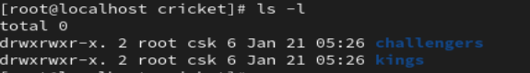
- Remove all permissions for others from both the kings and challengers directories.
